EVACUATION ALERT RESCIND
September 11, 2017 at 10:00 hours

The Evacuation Alert issued on September 2, 2017 at 20:30 hours pursuant to the Emergency Program Act, to the area on the east side of Koocanusa Lake from the Elk River bridge south to the US border between Highway 93 and Lake Koocanusa, including the Tobacco Plains Indian Reserve as outlined on the map attached, is rescinded.

For more information contact the information line at 250-426-2188 or 1-855-346-2188.

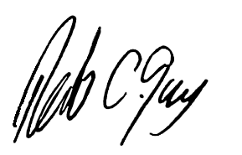

Rob Gay, Chair Tanya Brewer, Band Administrator
Regional District of East Kootenay Tobacco Plains Indian Band

